CHAPTER 3 FOR LOOP CONTINUATION

Pattern Printing:
Eg.
package ch3_pattern_printing;

public class Patern_Ab {
public static void main(String[] args)
{
int n= 5;

for (int i = 1; i <= n; i++) {
char ch = 'A';

for (int j = 1; j <= i; j++) {
System.out.print(ch + " ");
ch++;
}

System.out.println();
}
}

}

O/P:
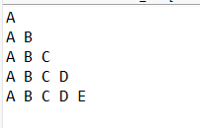

Eg.
package ch3_pattern_printing;

public class Star {

public static void main(String[] args) {
// TODO Auto-generated method stub
for(int i=0;i<5;i++)
{
for(int j=0;j<5;j++)
{
if(i==j)
{
System.out.print("*");
}
else
{
System.out.print(" ");
}
}
System.out.println();

}
}
}
O/P:


